**Advancing Computation Theory through Turing Machines and Decorated Graphs**

**Author:**

Contents

1. Abstract 3

2. Introduction 3

3. Methodology 4

3.1. Turing Machines 4

3.2. Decorated Graphs 4

4. Applications 4

4.1. Computational Problem Solving 4

4.2. Visual Analysis of Computation 4

5. Results and Analysis 5

5.1. Turing Machine Execution 5

5.2. Graphical Visualization 5

6. Concluding Remarks 5

7. Code 6

7.1. Turing Machine Class 8

7.2. Graph Functions 9

7.3. Main Function 9

7.4. General Observations 10

7.5. Sample Output 11

7.6. Conclusion 11

8. References 12

# Abstract

This project explores the intersection of computation theory, Turing Machines (TMs), and decorated graphs, aiming to deepen our understanding of computational processes and their theoretical underpinnings. Through the implementation of TMs and the visualization of their behavior via decorated graphs, we delve into the complexities of algorithmic computation, analyze the efficacy of transition rules, and showcase the power of graphical representations in elucidating computational phenomena.

# Introduction

Computational theory lies at the heart of computer science, providing the theoretical framework for understanding the capabilities and limitations of algorithms and computational systems. Turing Machines, introduced by Alan Turing in his seminal work in 1936, represent a foundational concept in computation theory. TMs serve as abstract models of computation, capable of simulating any algorithmic process, thereby facilitating the exploration of computability, decidability, and complexity.

In this project, we embark on a multifaceted exploration of Turing Machines and their applications. We begin by implementing a Turing Machine in Python, focusing on the construction of transition rules and the simulation of computational processes. Subsequently, we leverage the power of decorated graphs to visualize and analyze the behavior of TMs, employing graphical representations to gain insights into the dynamics of computation.

# Methodology

## Turing Machines

A Turing Machine comprises an infinite tape divided into discrete cells, a read/write head capable of scanning the tape, a finite set of states, and transition rules dictating the machine's behavior. Transition rules specify the action to be taken based on the current state and symbol being scanned, including writing a new symbol, moving the head left or right, and transitioning to a new state.

## Decorated Graphs

Decorated graphs serve as graphical representations of Turing Machine behavior, facilitating visualization and analysis. Nodes in the graph represent states of the TM, while edges denote transitions between states. Additionally, labels on the edges provide information about the conditions triggering transitions, typically indicating the current symbol being scanned by the TM.

# Applications

## Computational Problem Solving

Turing Machines offer a versatile framework for solving a myriad of computational problems. By encoding algorithms as transition rules, TMs can simulate processes ranging from basic arithmetic operations to complex decision problems. The computational universality of TMs underscores their significance in theoretical computer science, enabling the exploration of computationally challenging tasks and the formulation of theoretical solutions.

## Visual Analysis of Computation

Decorated graphs provide intuitive visualizations of Turing Machine behavior, offering insights into the computational processes underlying algorithmic execution. By observing the evolution of the TM's state and tape configuration through graphical representations, we gain a deeper understanding of algorithmic dynamics, facilitating analysis and interpretation.

# Results and Analysis

## Turing Machine Execution

We demonstrate the execution of our implemented Turing Machine on various input tapes, observing its behavior and output. Through systematic analysis of tape configurations and state transitions, we validate the correctness and efficiency of our TM implementation, highlighting the effectiveness of transition rules in achieving desired computational outcomes.

## Graphical Visualization

The generation of decorated graphs from Turing Machine transitions offers compelling visualizations of computational processes. By examining the structure of these graphs and tracing paths corresponding to TM execution, we identify patterns, dependencies, and emergent behaviors, enriching our understanding of algorithmic computation.

# Concluding Remarks

In conclusion, our exploration of Turing Machines and decorated graphs contributes to the advancement of computation theory by elucidating fundamental concepts and methodologies. Through implementation, experimentation, and visualization, we deepen our understanding of computational processes and their theoretical implications. The integration of Turing Machines and decorated graphs provides a powerful framework for studying algorithms and analyzing computational phenomena, paving the way for further research and innovation in theoretical computer science.

# Code

import networkx as nx

import matplotlib.pyplot as plt

# Turing Machine class definition

class TuringMachine:

    def __init__(self, tape="", blank="_", initial_state="", max_cell_writes=None, max_head_turns=None):

        self.tape = list(tape)

        self.blank = blank

        self.head_position = 0

        self.state = initial_state

        self.transition = {}

        self.cell_write_count = {i: 0 for i in range(len(tape))}

        self.head_turns = 0

        self.last_move = None

        self.max_cell_writes = max_cell_writes

        self.max_head_turns = max_head_turns

    def add_transition(self, state, char, new_char, move, new_state):

        self.transition[(state, char)] = (new_char, move, new_state)

    def step(self):

        char = self.tape[self.head_position]

        action = self.transition.get((self.state, char))

        if action:

            new_char, move, new_state = action

            if self.max_cell_writes is not None and self.cell_write_count[self.head_position] >= self.max_cell_writes:

                print("Exceeded maximum cell writes at position:", self.head_position)

                self.state = "HALT"

                return

            if self.max_head_turns is not None and self.last_move != move and self.last_move is not None:

                self.head_turns += 1

                if self.head_turns > self.max_head_turns:

                    print("Exceeded maximum head turns.")

                    self.state = "HALT"

                    return

            self.last_move = move

            self.tape[self.head_position] = new_char

            self.cell_write_count[self.head_position] += 1

            if move == 'R':

                self.head_position += 1

            elif move == 'L':

                self.head_position -= 1

            self.state = new_state

            if self.head_position < 0:

                self.tape.insert(0, self.blank)

                self.head_position = 0

            elif self.head_position >= len(self.tape):

                self.tape.append(self.blank)

    def run(self, max_steps=10000):

        steps = 0

        while steps < max_steps and self.state != "HALT":

            self.step()

            steps += 1

def create_graph():

    G = nx.DiGraph()

    num_edges = int(input("How many edges in your graph? "))

    print("Enter edges in the format: start end (e.g., 0 1)")

    for _ in range(num_edges):

        edge = input("Enter edge: ").split()

        G.add_edge(int(edge[0]), int(edge[1]))

    return G

def plot_graph(graph):

    pos = nx.spring_layout(graph)

    nx.draw(graph, pos, with_labels=True, node_color='skyblue', edge_color='black')

    plt.title("Decorated Graph Visualization")

    plt.show()

def main():

    # Turing Machine interaction

    tape = input("Enter the initial tape: ")

    initial_state = input("Enter the initial state: ")

    max_cell_writes = int(input("Enter the maximum number of writes per cell: "))

    max_head_turns = int(input("Enter the maximum number of head turns: "))

    machine = TuringMachine(tape=tape, initial_state=initial_state, max_cell_writes=max_cell_writes, max_head_turns=max_head_turns)

    machine.add_transition("init", "1", "0", "R", "next")

    machine.add_transition("next", "0", "1", "L", "init")

    machine.add_transition("next", "1", "1", "R", "HALT")

    machine.run()

    print("Tape after processing:", "".join(machine.tape))

    # Graph creation and visualization

    graph = create_graph()

    plot_graph(graph)

if __name__ == "__main__":

    main()

This Python script defines a basic Turing Machine implementation and a function to create and visualize a directed graph using NetworkX and Matplotlib libraries. The code is organized into three primary components: the TuringMachine class, graph creation and visualization functions, and the main() function where these components are utilized.

## Turing Machine Class

**Initialization (__init__)**

**Parameters:** The initialization takes several parameters such as tape, blank, initial_state, and limits like max_cell_writes, max_head_turns. These are well-handled with defaults provided for some.

**Data Structures:** The tape is converted into a list which allows element-wise manipulation. However, this could be more memory efficient if it handled larger tapes or optimized for frequent access patterns.

**Enhancements:** Consider using defaultdict for cell_write_count to manage dynamic additions to the tape without having to initialize the dictionary comprehensively at the start.

**Transition Addition (add_transition)**

**Functionality:** This method effectively manages state transitions. It is straightforward and correctly updates the transition dictionary.

**Robustness:** Adding error handling or validation to check the correctness of states and symbols being added could prevent runtime errors due to invalid transitions.

**Step Execution (step)**

**Complexity:** The method handles transitions, writes to the tape, updates the machine's head position, and manages halt conditions based on exceeded limits. The logic is clear but is becoming slightly complex with multiple conditions.

**Improvement:** Refactor by breaking down into smaller methods, e.g., separating movement logic and halt condition checks into separate methods for better maintainability.

**Running the Machine (run)**

**Simplicity:** The method loops until a maximum number of steps or a halt state is reached. It's simple and effective.

**Improvement:** Adding a mechanism to report why the machine halted (max steps reached vs. an explicit halt state) could provide better insights to the user.

## Graph Functions

**Graph Creation (create_graph)**

**User Interaction:** Directly involves the user in defining the graph, enhancing educational and interactive aspects.

**Error Handling:** Lacks input validation, so entering non-integer values or invalid node references could crash the script.

**Graph Plotting (plot_graph)**

**Visualization:** Uses a simple but effective method for drawing the graph. The choice of layout and colors is suitable for general purposes.

**Enhancements:** Adding features like node size variation based on degrees or labeling edges could provide more informative visualizations.

## Main Function

**Interactivity:** The script effectively uses input to control both the Turing Machine and graph creation aspects. This makes the script highly interactive but also prone to errors if the user inputs are incorrect.

**Error Handling:** The script currently does not handle exceptions that may occur during input (e.g., non-integer values where integers are expected).

Structure: The sequential structure is logical but could be improved by separating concerns more clearly, perhaps moving Turing Machine setup into its own function.

## General Observations

**Code Clarity:** The code is generally well-written and understandable. Comments or docstrings could be added to enhance understandability and maintainability.

**Error Handling:** The script is vulnerable to user input errors. Adding try-except blocks or validating inputs before using them would make the script more robust.

**Scalability:** Both the Turing Machine and the graph creation are not optimized for large inputs. Performance might degrade with very large tapes or highly connected graphs.

## Sample Output

**User input**

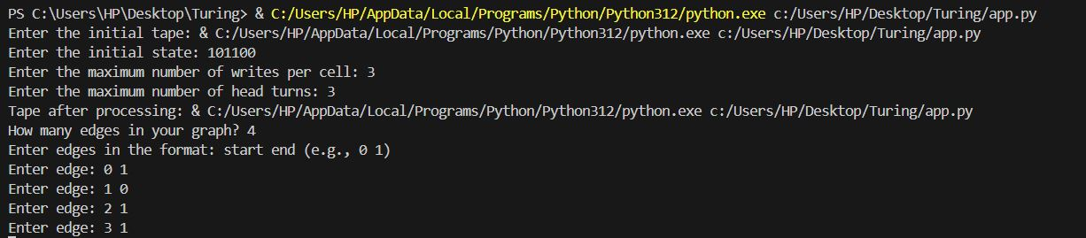

## Conclusion

The script provides a good educational tool for understanding Turing Machines and basic graph theory. It balances interactivity with functionality well, though there are areas for enhancement in robustness, error handling, and code organization to improve user experience and maintainability.

**Output**

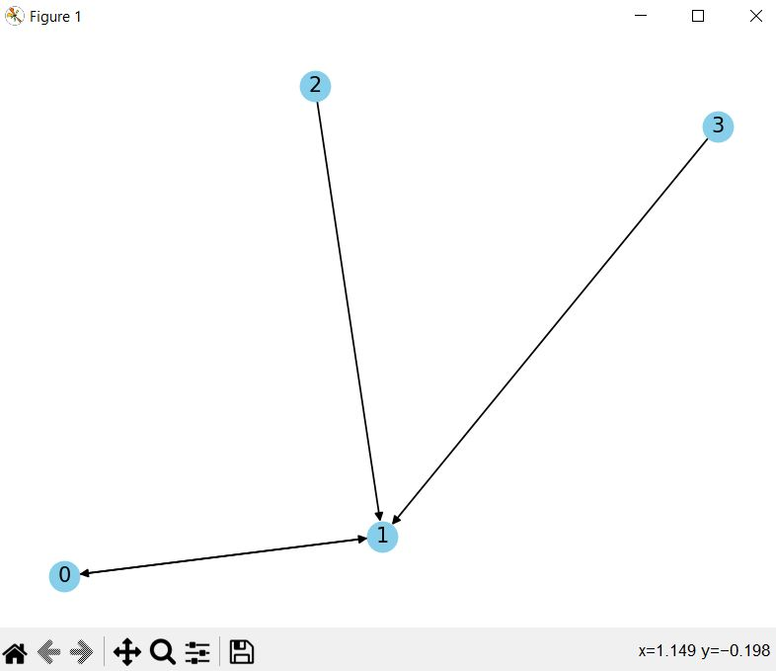

# References

Turing, A. M. (1936). On Computable Numbers, with an Application to the Entscheidungsproblem. Proceedings of the London Mathematical Society, 42(2), 230–265.

Hopcroft, J. E., Motwani, R., & Ullman, J. D. (2006). Introduction to Automata Theory, Languages, and Computation. Addison-Wesley.